Software Requirement Specification Document

For
Cold Storage Management System

Table of Contents
Page Numbers
- Introduction
  - Purpose 3
  - Intended Customers/Users 3
  - Product Scope 3
  - Outline of the document 3
- Overall Description
  - Product Perspective 4
  - Product Functions 4
  - User Classes 4-5
  - Design and Implementation Constraints 5
- Diagrams
  - UML Diagrams 5-24
  - ER Diagrams 24
  - DFD Diagrams 25
- External Interface Requirements/Screenshots
  - User Interfaces 25
  - Hardware Interfaces 26
  - Software Interfaces 26
  - Communication Interfaces 26
- Other Non-Functional Requirements
  - Performance Requirements 27
  - Safety Requirements 27
  - Security Requirements 28
  - Software Quality Attributes 28
  - Business Policies/Rules (if any) 29
- Testing
  - White-Box Testing 29-32
  - Black-Box Testing 32-35
- Conclusion 35
- References 36
- Acknowledgements 36

- INTRODUCTION
  - PURPOSE
- To help farmers to find a cold storage location available in nearby location.
- This software mainly helps in providing an optimized way to use the cold storage facilities based up on the crop type, quantity of the crop.
- This software allows the farmers for booking the storage slots and managing the crop life after harvesting and connects the storage owners and farmers to ensure fair access and operational efficiency.
- This platform also gives updates for farmers about the crop thought the storage period, by this software we can use the capacity of storage effectively.
- This SRS document describes all the functional, non-functional, design and all other requirements for this project.

  - INTENDED CUSTOMERS / USERS
- Farmers:Farmers can login to the platform and access the locations of the cold storages nearby and also book a slot in cold storage depending the quantity and type of the crop.
- Cold Storage Staff/Owner:Staff can access the platform and check the bookings according to the slots availableand help farmers to store the harvested crop.
- Administrator: Administrator can able to see how many slots available and how many are booked,also the time period of the booked slots.

  - PRODUCT SCOPE
- Online Booking of Crop Based Slots.
- Selection of a Crop type.
- Selection of S
- Selection of Date and Time Slot.
- Viewing of daily bookings of slots in cold storage.
- Helps finding the location of cold storages available in nearby distance.
- Displaying the payment status.
- Simple and user-friendly web interface.

  - OUTLINE OF THE DOCUMENT
- The rest of the SRS document contains five more chapters starting from chapter 2 to chapter 6.
- Chapter 2 explains the following topics like perspective of the product, functions this software provides, user classes and constraints to be followed.
- Chapter 3 contains UML Diagrams, ER Diagrams and other diagrams required while developing this software.
- Chapter 4 describes the functional requirements like User, Hardware, Software and Communication interfaces required for development of this project.
- Chapter 5 talks about the non-functional requirements like usability, security needs and performance.
- Chapter 6 deals about the testing and constraints of the project.
- OVERALL DESCRIPTION
  - PRODUCT PERSPECTIVE
- The system is a web-based application.
- It works as a standalone system.
- It can be accessed using a web browser.
- It uses a backend database to store booking details.
- No dependency on external hardware devices.
- It may interact with:Database system for storing service records and Calendar/date system for slot management.

  - PRODUCT FUNCTIONS
- User(farmer) Registration and Login
- Selection of cold storage location
- Selection of slot duration
- Selection of available date and time slot
- Booking Confirmation Display
- Storage of booking details in database
- Viewing daily bookings by cold storage staff
- Allocating the slot by checking payment status
- Viewing number of booked slots and slots filled with type of crop
- Viewing slots booked by single day

  - USER CLASSES
- Farmer
- Registration and login to the system.
- Selectionof the crop type.
- Selecting the location.
- Selection of the required storage duration.
- Booking a slot.
- Checking the booking status.
- Timely storages updates and results.

- Storage Staff
- Registration and demonstrating facilities available.
- Define the temperature system and storage capacity.
- View the booked slots from the farmers.
- Approve or reject the farmer bookings.
- View daily bookings.
- Monitor already stored crop.
- View booked slots for each crop type.
- Administrator/Manager
- View reports of booking.
- Manage available slots.
- Monitor workload and resources.
- Resolve conflicts regarding the bookings.
- Sending the updates to farmers.

  - DESIGN AND IMPLEMENTATION CONSTRAINTS
- The system must run on a web browser.
- Requires a stable internet connection.
- Limited to basic hardware (PC/Laptop/Mobile).
- Works best on modern browsers (Chrome, Edge, Firefox).
- Performance depends on server availability.
- Security constraints for protecting user booking data.
- Slot availability is limited to predefined time slots.
- System functionality depends on correct date and time settings.

- DIAGRAMS:
  - UML Diagrams:
    - Use Case Diagrams:
This project Crop Centric Cold Storage Management System contains five modules. The Modules includes Actors, Use Cases and relationships between Actor and Use Case.
- User Management Module: It is responsible for handling registration of user, authentication of user and authorization within system.it provides secure access by validating user credentials and assigning role-based permissions. Here Farmer is the primary actor and Administrator, Cold Storage Owner are secondary actors.
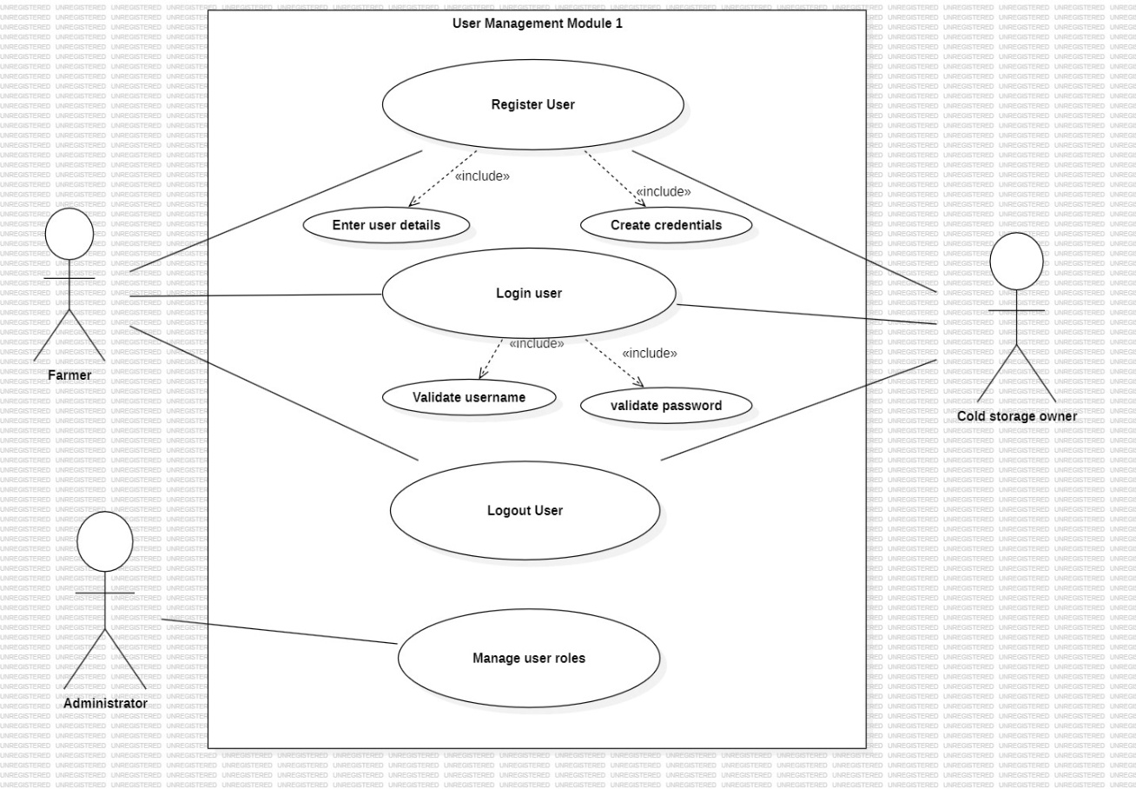

- Farmer Operations Module: This module permits farmers to interact with system by providing croprelated information and tracking their stored produce. This module also focuses on user input and visibility. Here Farmer is the primary and only actor.
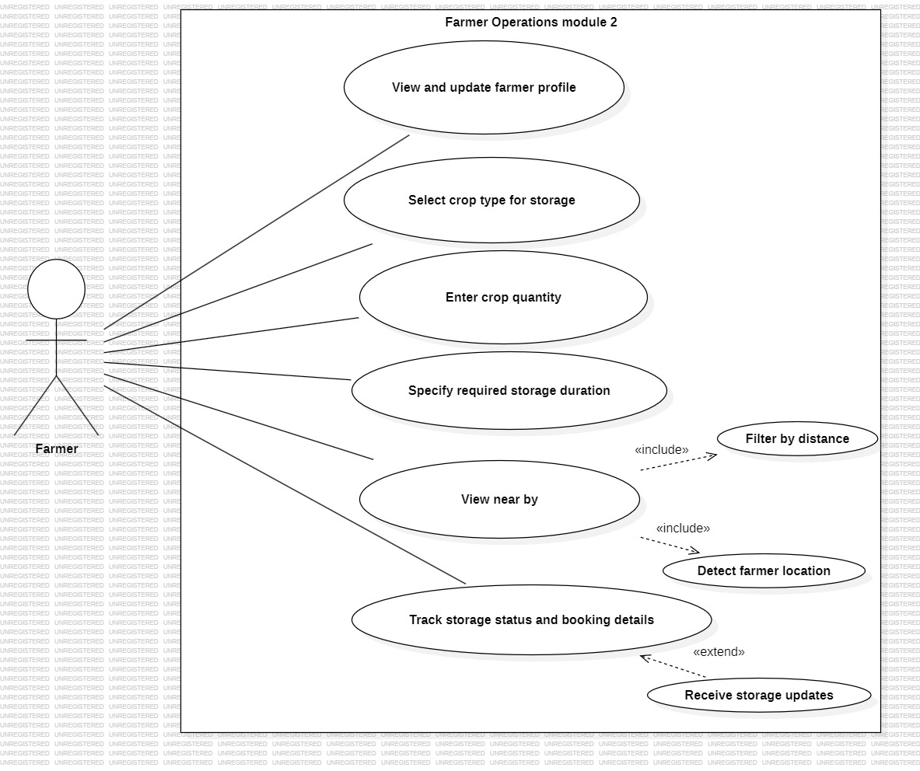
- Cold Storage Management Module: This module handles the configuration and management of cold storage facilities. It ensures that storage capacity, conditions and availability are properly maintained. Here Cold Storage Owner is the primary actor and Administrator is secondary actor.
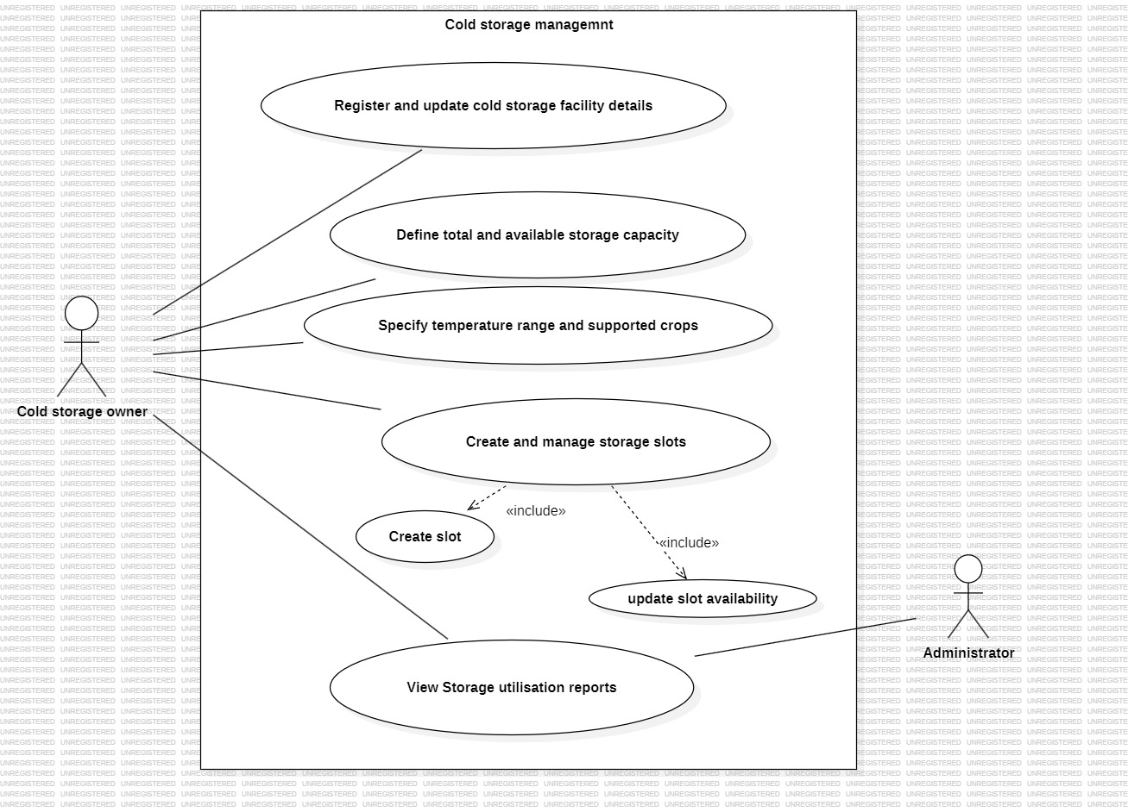

- Slot Booking and Allocation Module: Thisis the core module of this system. It handles the process of checking availability, booking storage slots and allocating space based on crop-type, quantity, duration and location. Here Farmer is the primary actor and Cold Storage Owner is the secondary actor.
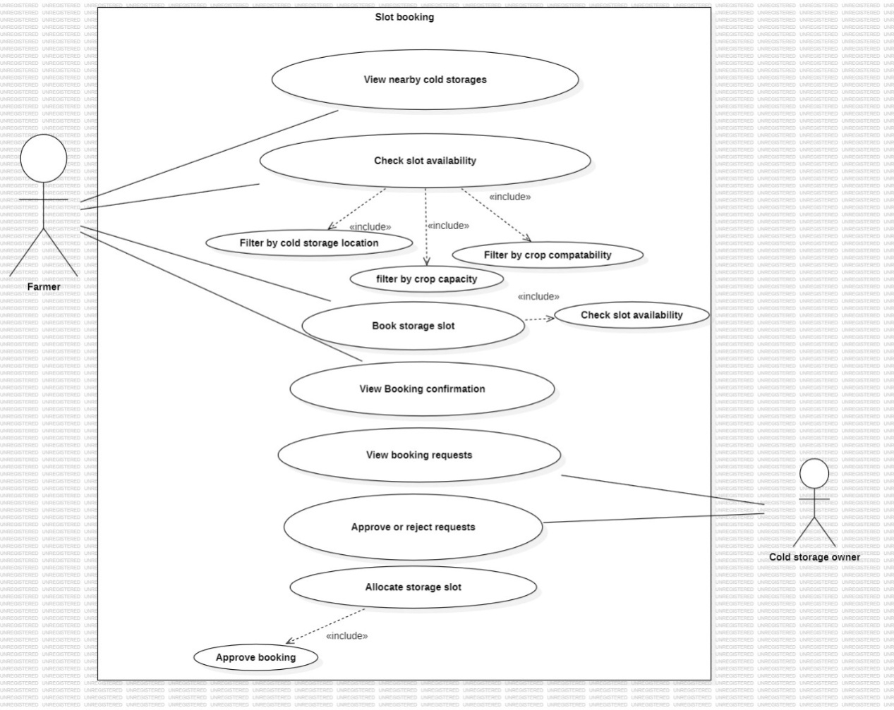

- Notification and Monitoring Module: Thismodule allows continuous tracking of stored crop and communicates important updates to users throughout the storage period. Here Farmer is the primary actor and Cold Storage Owner is the secondary actor.
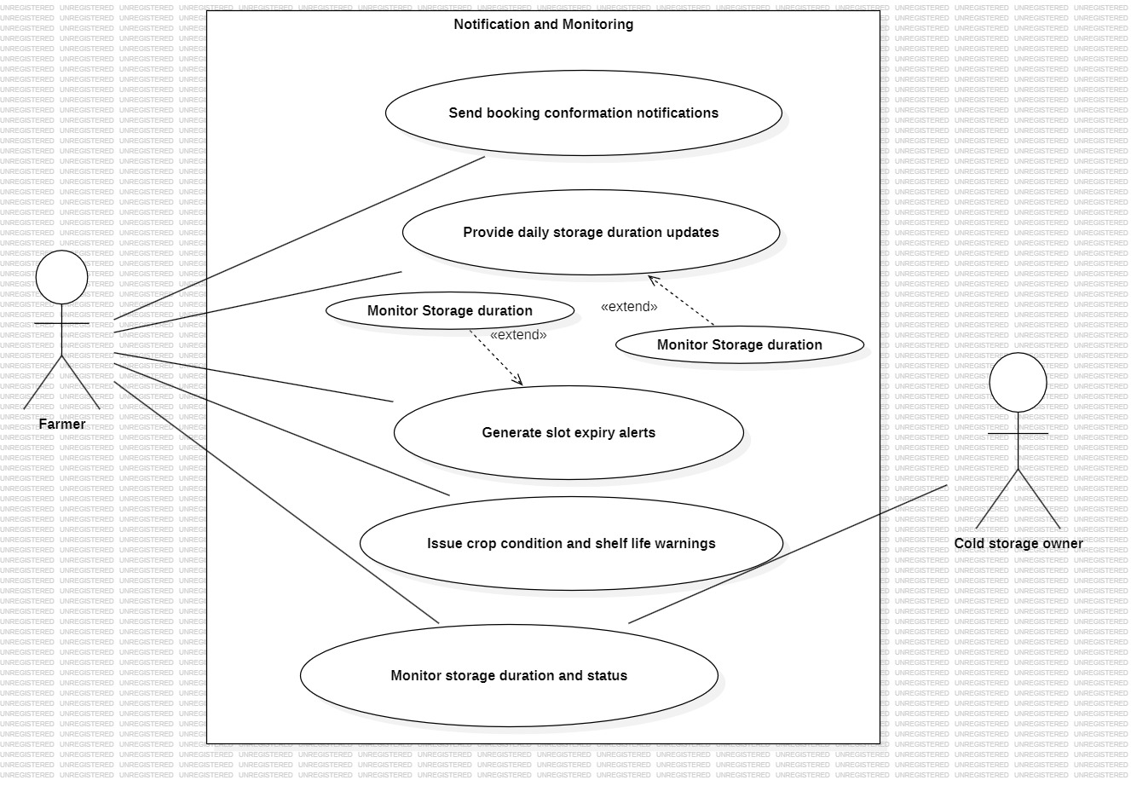

    - Class Diagrams:
- User Management Module: This class diagram defines a base User class that handles common authentication and identification features. Farmer, ColdStorageOwner, and Administrator are specialized subclasses that inherit from User using generalization. This design ensures role-based access while avoiding duplication of common user functionalities.
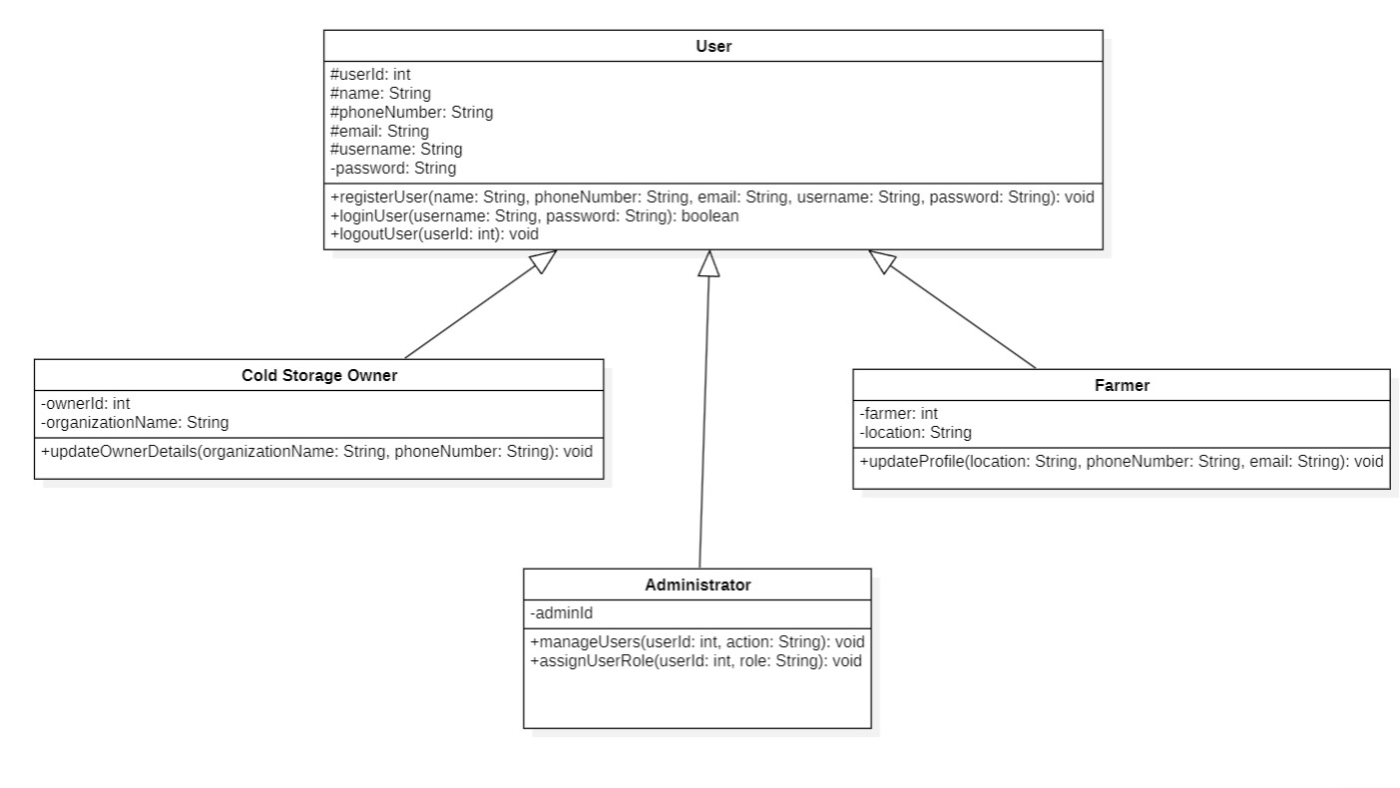

- Farmer Operations Module: This diagram models farmer-specific operations involving crop selection and profile management. A composition relationship exists between Farmer and FarmerProfile, indicating strong ownership. An association between Farmer and Crop allows a farmer to interact with multiple crops.
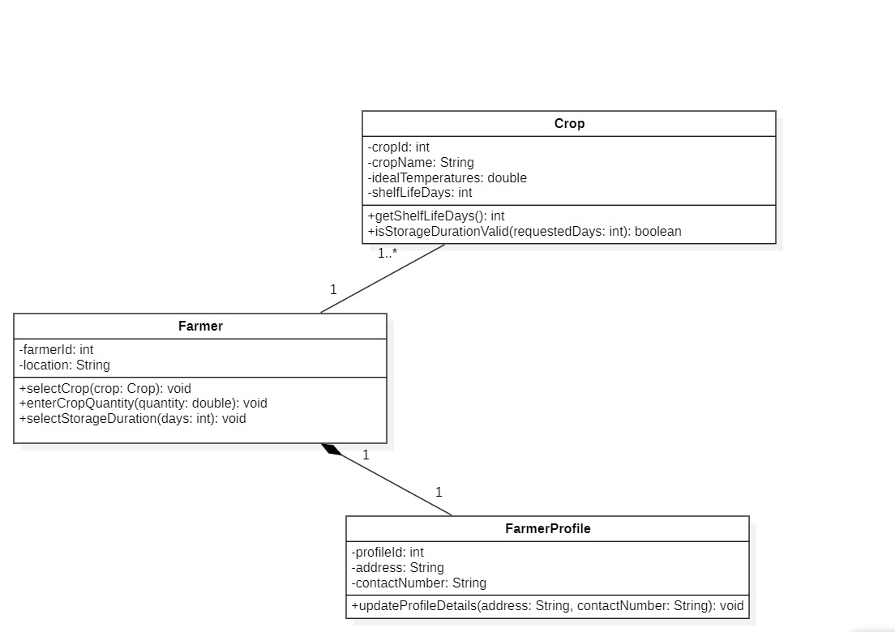

- Cold Storage Management Module: This diagram represents the structure and management of cold storage facilities. ColdStorage composes multiple StorageSlot objects, indicating that slots depend on the storage. ColdStorageOwner is associated with one or more cold storage units for management purposes.
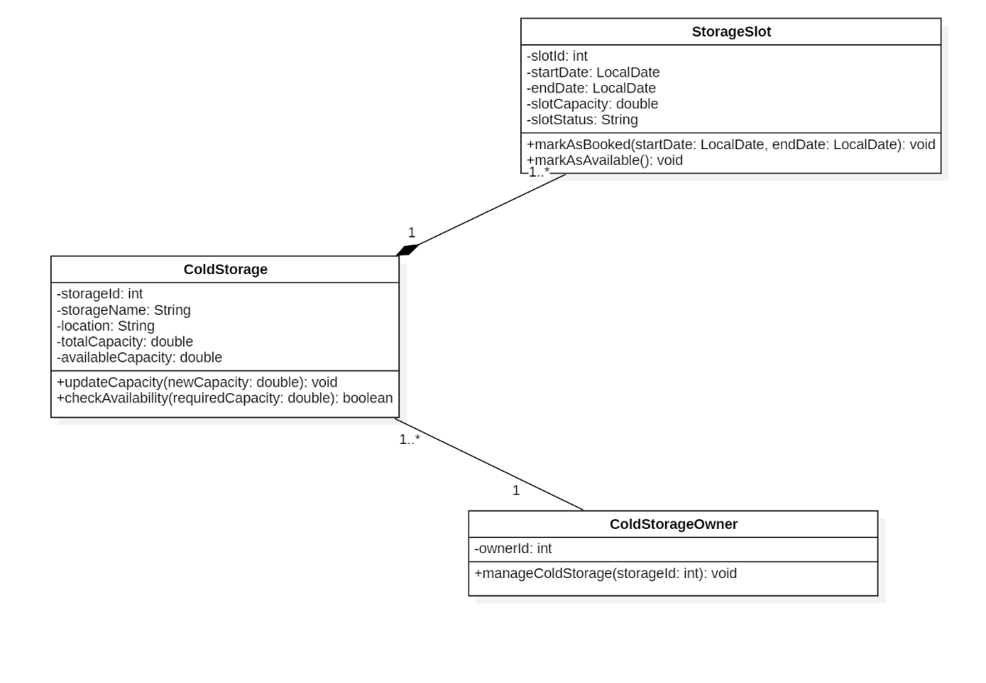

- Slot Booking Allocation Module: This diagram models the booking and allocation process for cold storage slots. A Farmer can create multiple Bookinginstances; each linked to a single Crop and StorageSlot. Aggregation is used to show that storage slots are grouped under a cold storage facility.
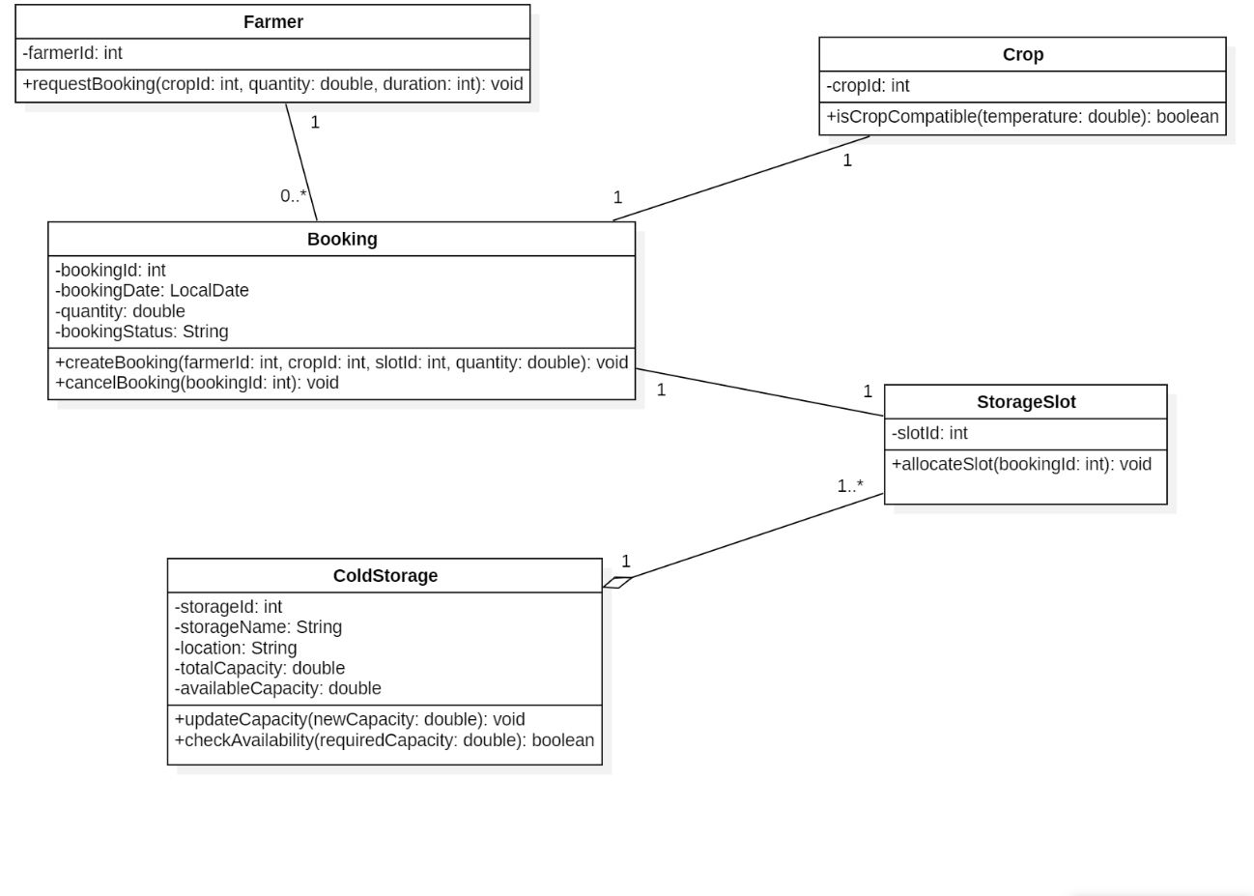

- Notification and Monitoring Module: This diagram handles storage monitoring and notification services. Each Booking can generate multiple Notification objects to inform users about storage status. The StorageMonitor class depends on booking data to calculate duration and expiry alerts.
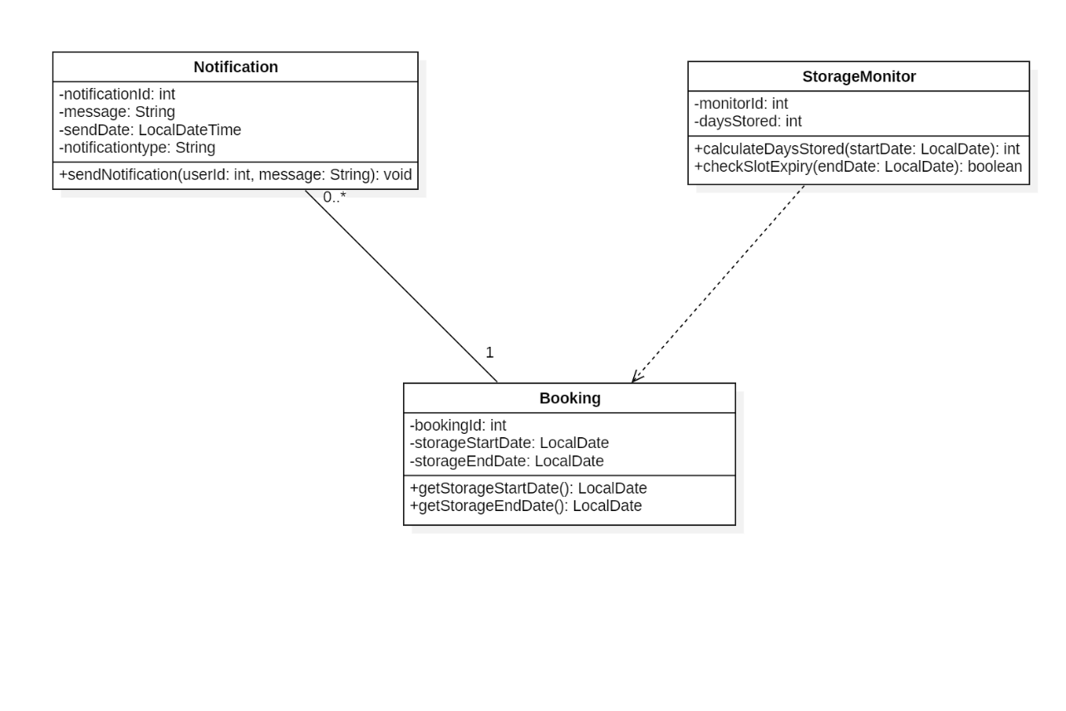
    - State Chart Diagrams:
For drawing the state chart diagrams, consider module –2(Farmer Operations Module). This module contains three classes Farmer, Crop and FarmerProfile which results in three state chart diagrams.

- Farmer: This state chart diagram represents the dynamic behaviour of the Farmer class in the Farmer Operations module. It models the sequence of states a farmer goes through while interacting with the system, including login, crop selection, quantity entry, and storage duration selection. State transitions occur based on farmer actions and system responses. The diagram ends when the farmer completes the booking process or exits the system.
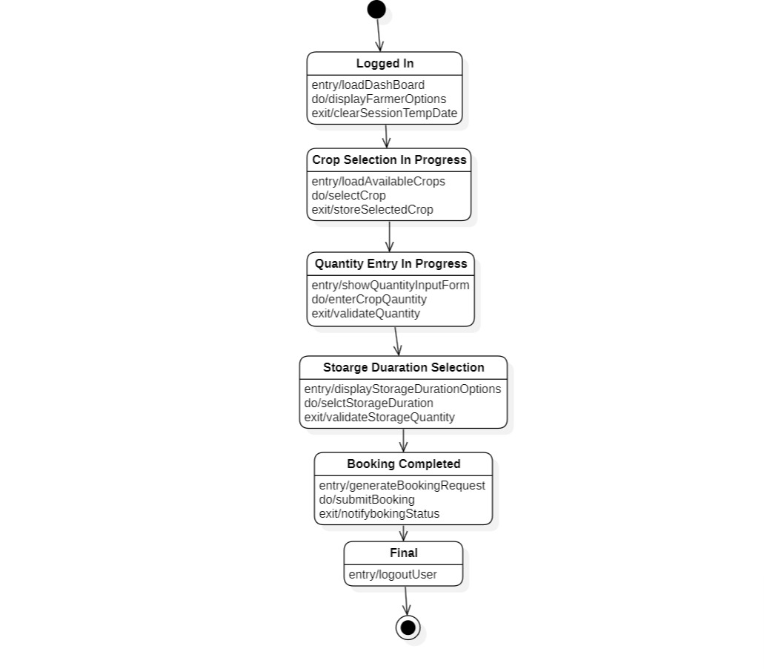

- Crop: This state chart diagram illustrates the behaviour of the Crop class during the storage request process. It focuses on validating the requested storage duration against the crop’s shelf life. Guard conditions are used to represent valid and invalid storage duration scenarios. The diagram terminates after the validation result is determined.

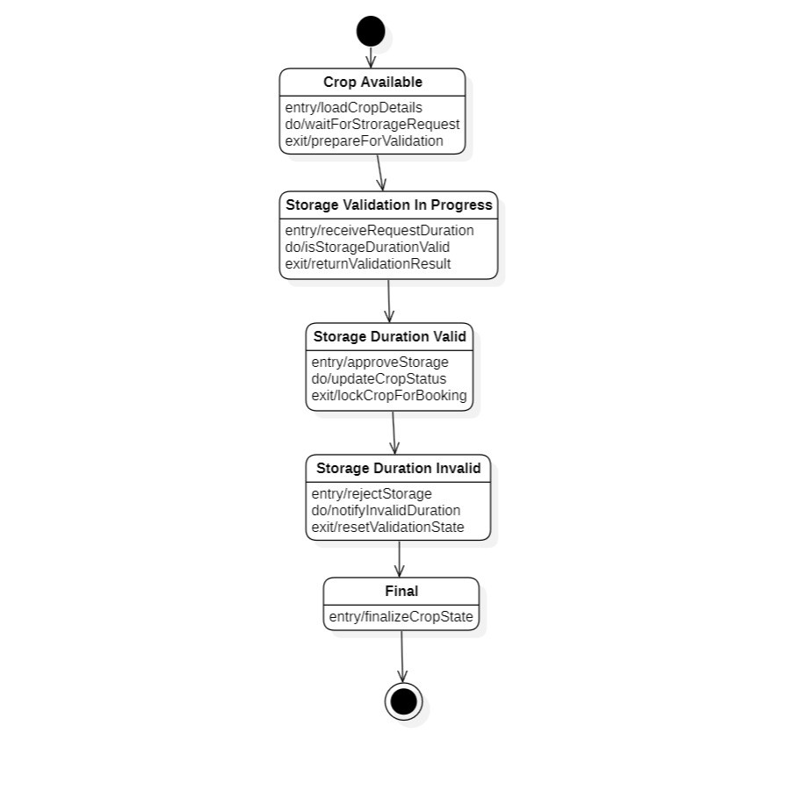

- Farmer Profile: This state chart diagram models the lifecycle of the FarmerProfile class within the Farmer Operations module. It shows states related to profile creation, update requests, and profile updates. State transitions are triggered when the farmer modifies personal information. The diagram concludes once the profile details are successfully updated and saved.
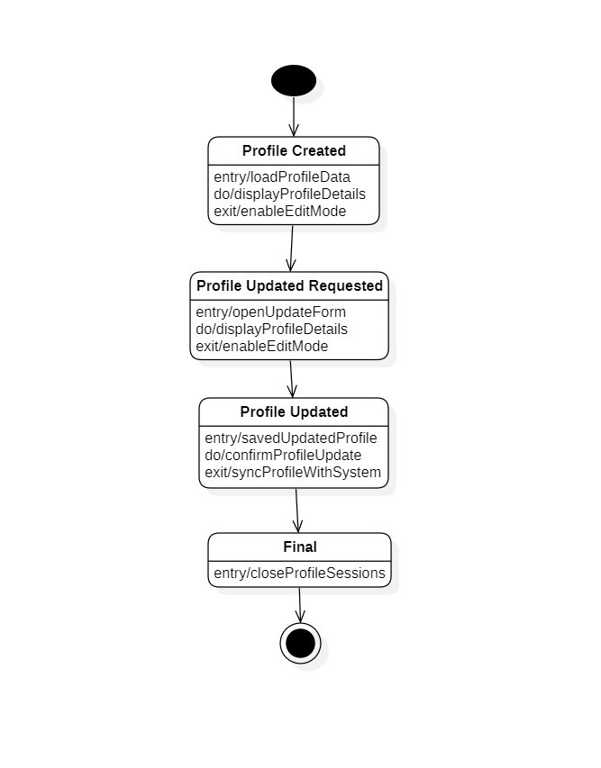

    - Activity Diagram:
The activity diagram represents the workflow of actions performed in the Farmer Operations Module. It illustrates the sequence of activities starting from farmer login, followed by crop selection, quantity entry, and storage duration selection. Decision nodes are used to validate user inputs and handle invalid scenarios by redirecting the flow. The diagram concludes with booking submission and confirmation, showing the complete operational process.
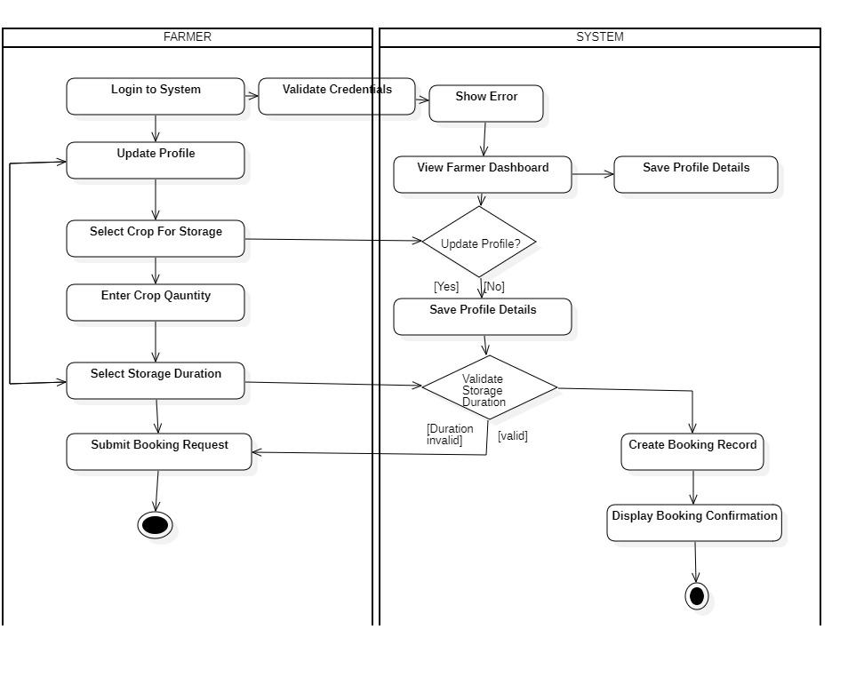

    - Sequence Diagrams:
Sequence diagrams are behavioural UML diagrams that represent how system components interact with each other in a time-ordered manner. They illustrate the flow of messages exchanged between actors and system objects to accomplish a particular functionality. These diagrams help in understanding the dynamic execution of operations and the responsibilities of each component. Sequence diagrams are useful for validating system logic and communication among modules.

- User Management Module:
This sequence diagram illustrates how a user interacts with the application to perform registration, authentication, and logout operations. The user sends requests to the application, which further communicates with the authentication system to validate credentials. Based on the response, the system returns either a success or failure message. The diagram captures the chronological order of communication required for secure access.
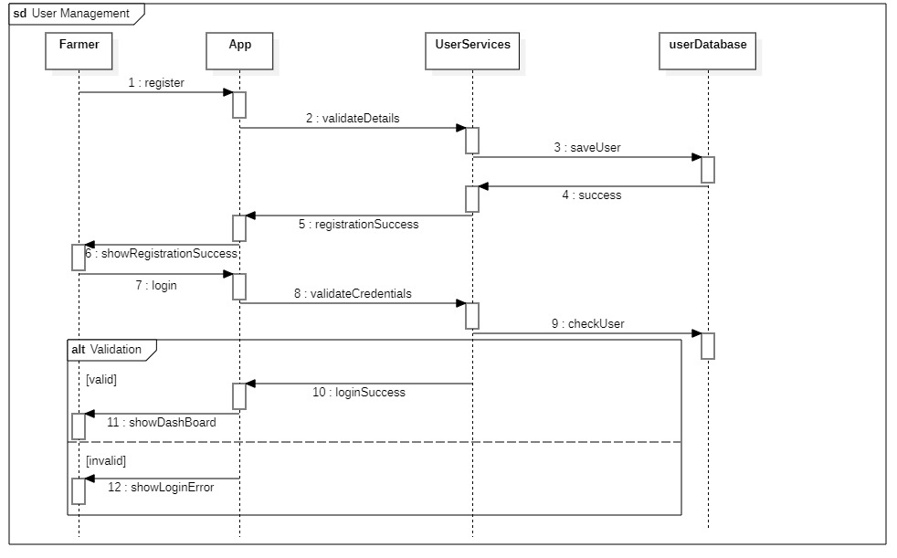

- Farmer Operations Module:
This diagram represents the interactions between the farmer and the system while submitting crop details for storage. The application communicates with the crop component to validate storage constraints and then proceeds to booking creation. Depending on validation results, the farmer receives either a confirmation or an error response. The sequence ensures correct coordination before finalizing storage allocation.

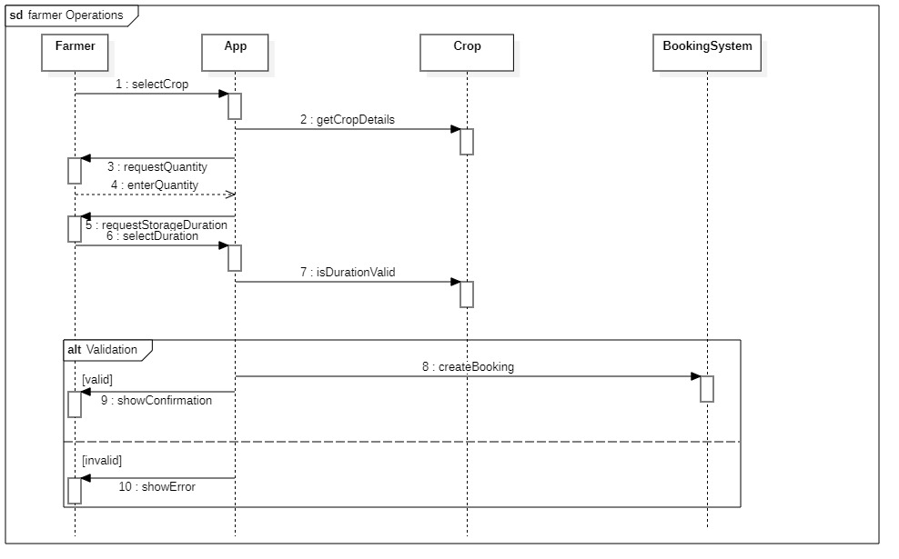

- Cold Storage Management Module:
This sequence diagram models how a storage owner updates infrastructure information within the system. The application forwards requests to storage and slot components to save details and generate availability. Responses are returned to confirm successful updates. The diagram highlights the cooperation between management services in maintaining accurate storage data.

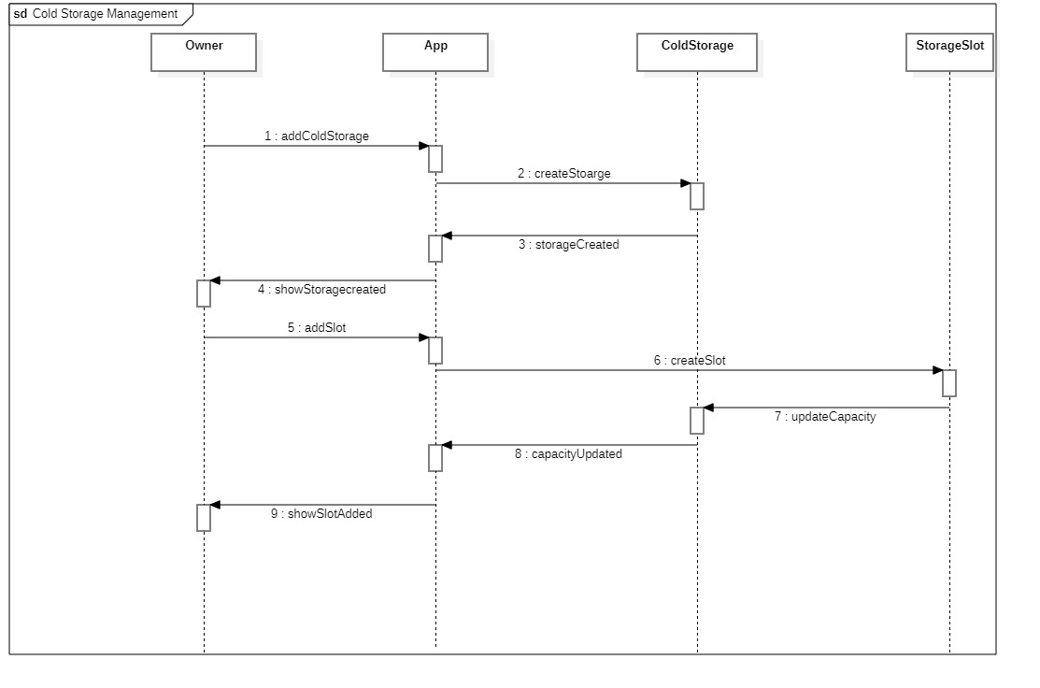

- Slot Allocation Module:
This diagram shows the process of assigning available storage slots to farmers. The application interacts with the slot manager to verify availability and communicates with the booking system to finalize reservations. After allocation, confirmation is delivered to the farmer. The sequence ensures fair and systematic distribution of storage capacity.

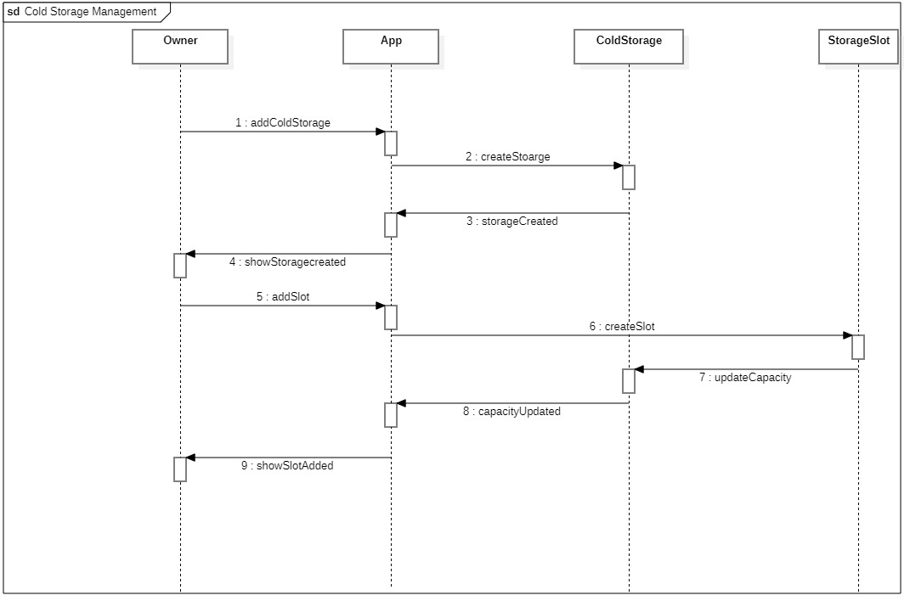

- Notification and Monitoring Module:
This sequence diagram illustrates how the system tracks stored crops and sends alerts to farmers. The booking component monitors timelines and triggers the notification service whenever attention is required. Farmers receive reminders or expiry alerts accordingly. The diagram emphasizes automated communication and timely updates.

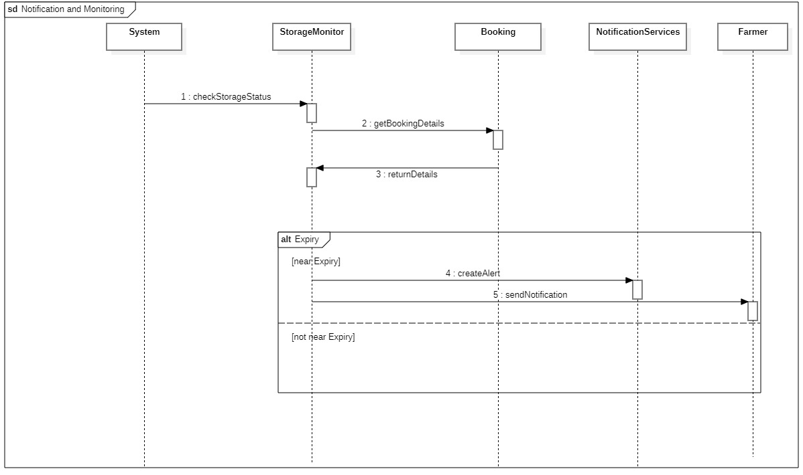

    - Collaboration Diagrams:
Collaboration diagrams describe how objects within the system cooperate to complete a task. Unlike sequence diagrams, they focus more on structural relationships rather than time flow. Messages are represented with numbered interactions that show the order of communication. These diagrams are useful for visualizing responsibilities and dependencies among components.
- User Management Module:
This diagram shows how the user, application, and authentication service collaborate during registration and login activities. Numbered messages indicate how requests are validated and responses are generated. It provides a structural understanding of security and identity management within the system.
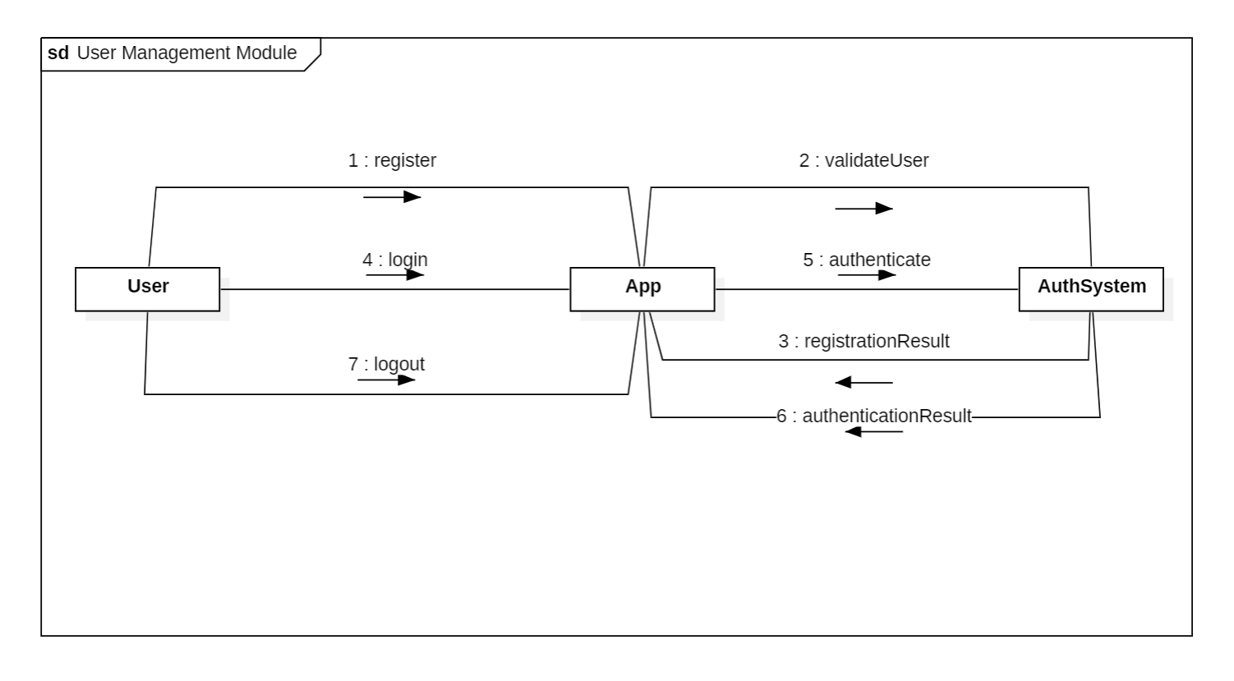

- Farmer Operations Module:
The collaboration diagram demonstrates how the farmer, application, crop module, and booking service work together for storage requests. Communication links highlight validation and reservation responsibilities. The numbered interactions clarify how booking decisions are derived.
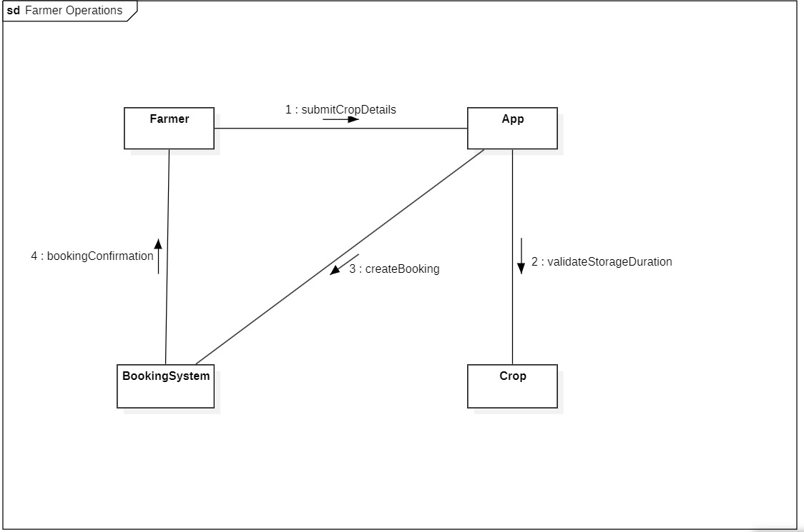

- Cold Storage Management Module:
This diagram illustrates cooperation between the owner, application, storage unit, and slot manager. Messages focus on updating infrastructure data and maintaining availability records. It ensures that system components share consistent information.
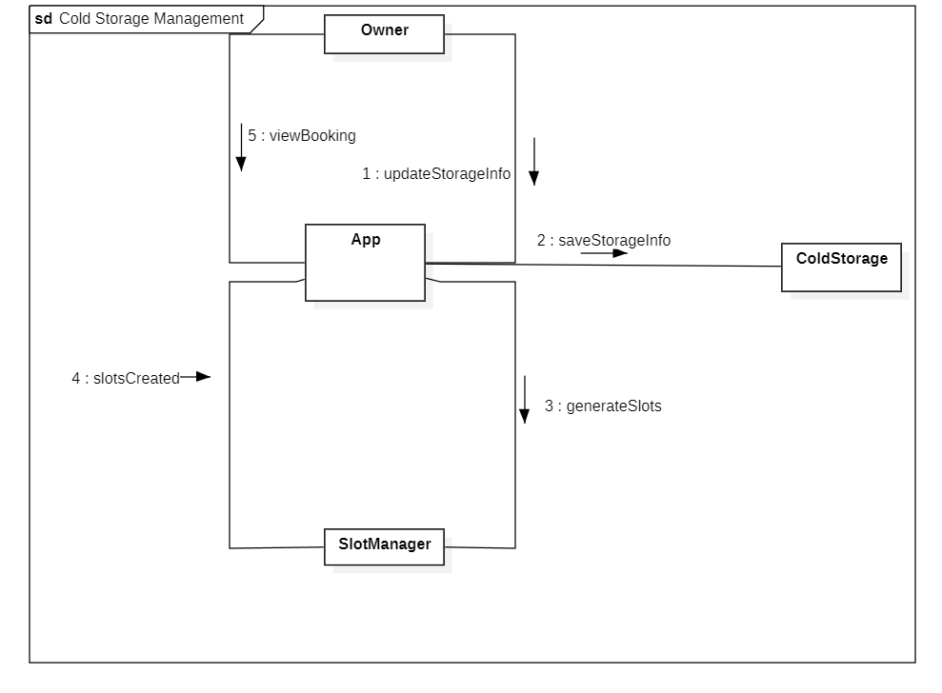

- Slot Allocation Module:
The collaboration view represents how booking requests propagate among the application, slot manager, and reservation system. Each object contributes to verifying and assigning resources. The message numbering clarifies the coordination required for allocation.
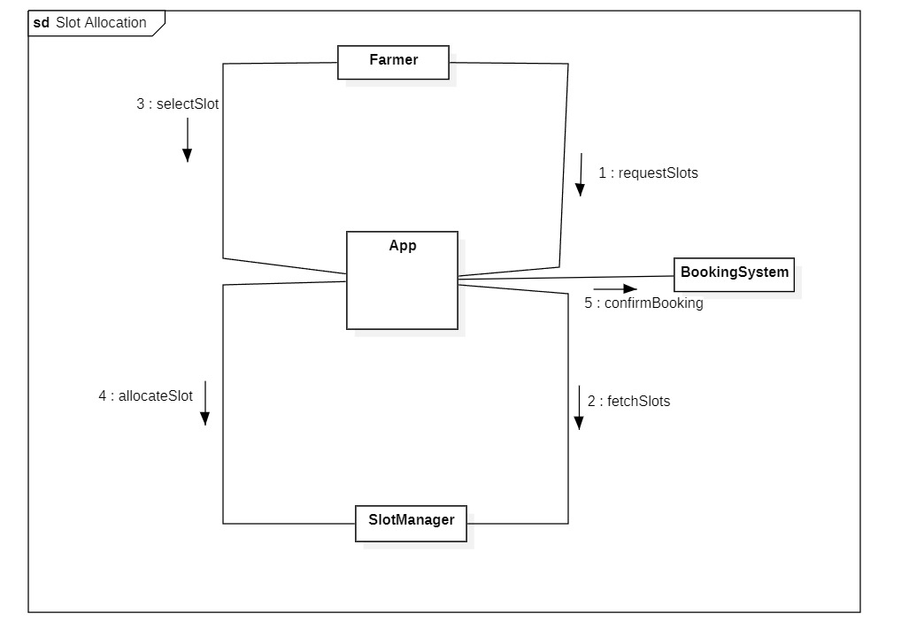

- Notification and Monitoring Module:
This diagram models how monitoring services interact with the notification component to keep farmers informed. Communication links show how alerts are generated and delivered. The structure highlights automated supervision of stored crops.
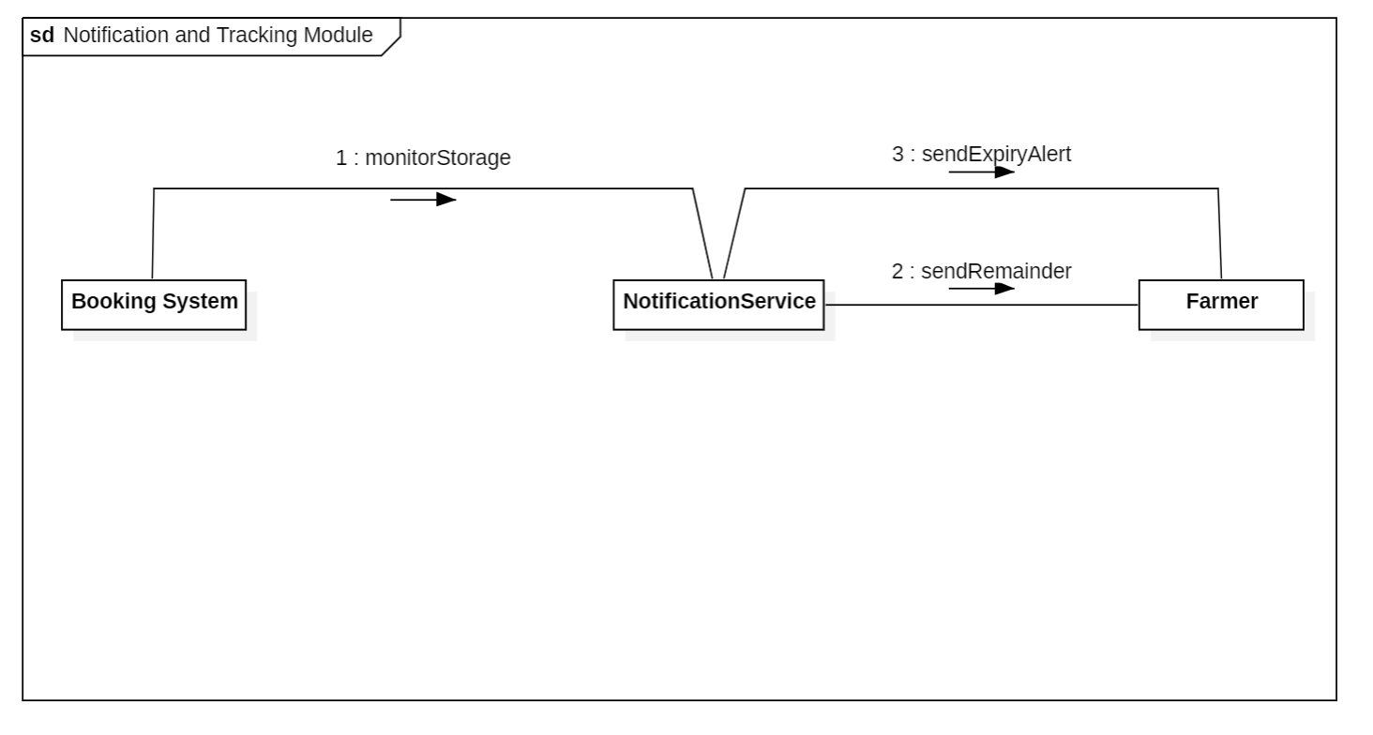

  - ER Diagram:
The ER diagram models the core data structure of the cold storage management system by representing farmers, cold storage, and bookings along with their relationships.

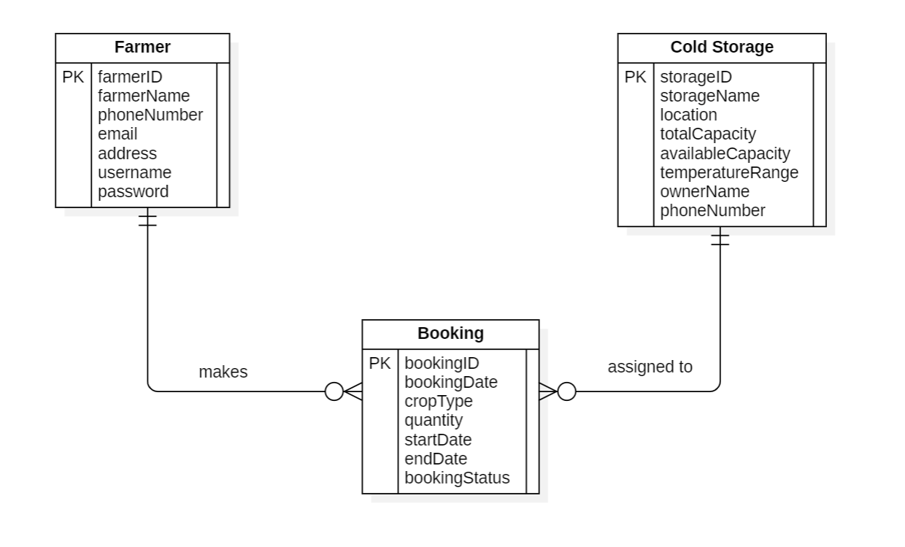

  - DFD Diagrams:
Level-1 Data Flow Diagram:

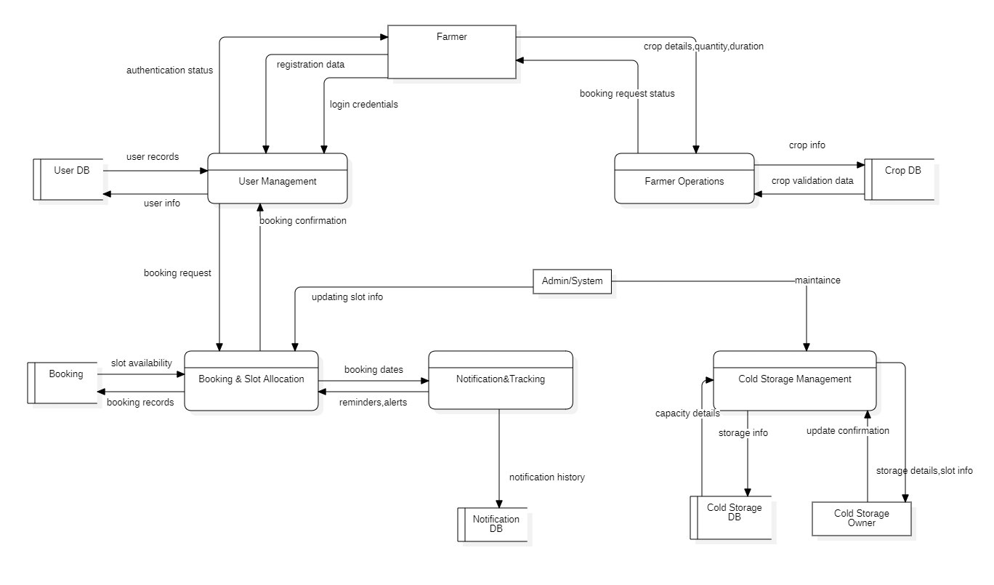

- EXTERNAL INTERFACE REQUIREMENTS/SCREENSHOTS
  - User Interfaces:
The user interface enables both farmers and cold storage owners to interact effectively with the system. Since the primary users of this project are farmers, many of whom may have limited technical knowledge or experience with mobile applications, special emphasis is placed on simplicity and ease of use. The interface is designed to guide users smoothly through each operation without causing confusion or difficulty.

Cold storage owners also use the system to manage storage details and bookings. While they may be more familiar with basic mobile applications, the interface remains clear and intuitive to ensure efficient operation for all users.

To achieve this, the system adopts a graphical user interface (GUI) that utilizes visual elements such as icons, buttons, and structured screens instead of complex text-based interactions. The interface is mobile-friendly, uses simple language, and includes large buttons with visual cues to support easy navigation. This approach enhances usability, reduces errors, and provides a comfortable user experience for both farmers and cold storage owners.

  - Hardware Interfaces:
The hardware interface describes the physical devices used to access and operate the system. The application is designed to run on commonly available devices so that both farmers and cold storage owners can use it without requiring any special equipment. This approach ensures affordability, ease of access, and practicality for real-world implementation.

The system runs on the following hardware components:
- Android smartphones for farmer and owner access.
- Desktop or laptop computers for extended management tasks.
- A central server to store and process system data.
- Internet connectivity through Wi-Fi or mobile data networks.

  - Software Interfaces:
For this project, commonly used application platforms and supporting software systems are selected to ensure reliability, ease of use, and scalability. The system is designed to operate through a mobile-based application supported by a backend service and a centralized database system. This combination allows secure storage of information, efficient processing of booking requests, and smooth interaction between users and system components.

A mobile application platform is chosen to provide easy accessibility for farmers and cold storage owners, as smartphones are widely available and convenient for daily use. A database management system is used to store user data, booking records, and cold storage information in an organized manner. Additionally, mapping and notification services can be integrated to enhance user experience by providing location-based storage suggestions and timely alerts.
The software systems used include:
- Mobile application platform (Android-based application environment).
- Relational database management system.
- Backend application server.
- Map and location services.
- Notification and messaging services.

  - Communication Interfaces:
The communication interface defines how information is exchanged between the mobile application, backend server, and external services. The system uses internet-based communication to enable real-time interaction for booking requests, storage updates, and notification delivery. This ensures that users always receive the latest information without delays.

To manage this communication efficiently, the system utilizes RESTful APIs. These APIs allow the mobile application to securely send requests such as user login, crop booking details, and storage queries to the backend server and receive responses in a structured format. REST APIs are chosen because they are lightweight, widely supported across platforms, easy to scale, and suitable for mobile-based applications with limited network resources.
Secure HTTPS protocols are implemented to protect data transmission and prevent unauthorized access to sensitive information.
The communication technologies used include:
- Internet connectivity via Wi-Fi or mobile data networks.
- RESTful APIs for structured client–server communication.
- HTTPS protocol for secure data transfer.
- Real-time data synchronization for booking and notification updates.

- OTHER NON-FUNCTIONAL REQUIREMENTS
  - Performance Requirements:
The system is designed to provide fast and reliable responses to users in order to ensure smooth operation and a positive user experience. Since farmers and cold storage owners rely on timely information such as storage availability and booking confirmation, the application must process requests efficiently without noticeable delays.
The system should support multiple users accessing the platform simultaneously while maintaining consistent performance. Database operations such as booking creation, user authentication, and availability checks should be optimized to ensure quick data retrieval and updates. The application should remain responsive even during peak usage periods.
Key performance expectations include:
- Quick response time for user actions such as login and booking requests.
- Efficient handling of multiple concurrent users.
- Fast data retrieval from the database.
- Minimal downtime and high system availability
- Smooth real-time updates for notifications and confirmations
  - Safety Requirements:
The system is designed to ensure the safe handling of user information and reliable operation of all booking and storage processes. Since the application manages important data such as personal details, booking records, and storage availability, appropriate measures are required to prevent data loss, unauthorized access, and system misuse.

The system must maintain data integrity during all operations, ensuring that bookings are processed correctly and stored securely. Regular backups should be performed to protect information from accidental loss or technical failures. Error-handling mechanisms should be implemented to prevent system crashes and guide users in case of incorrect inputs.
The system shall ensure safety through the following measures:
- Secure storage of user and booking data.
- Regular database backups and recovery mechanisms.
- Controlled access based on user roles.
- Input validation to prevent incorrect or harmful data entry.
- System monitoring to detect failures or abnormal activities

  - Security Requirements:
Protecting user information and operational data is a major priority of this project. Since the application manages sensitive details such as login credentials, personal profiles, and booking records, appropriate security mechanisms are necessary to prevent unauthorized access and data misuse.

User access is controlled through secure authentication methods, ensuring that only approved users can perform actions within the application. Different roles such as farmers, cold storage owners, and administrators are provided with limited access based on their responsibilities. Data exchanged between the mobile application and backend services is encrypted to maintain confidentiality. Stored information is also safeguarded using secure database practices to minimize security risks.
Security is ensured through the following measures:
- Secure login and authentication mechanisms.
- Role-based access permissions.
- Encrypted data transmission.
- Protected database storage.
- Regular monitoring for security threats.

  - Software Quality Attributes:
The quality of the software is essential to ensure that the application remains reliable, easy to use, and adaptable to future requirements. Since the system is intended for regular use by farmers and cold storage owners, it must provide consistent performance, minimal errors, and a smooth user experience. A well-structured design is maintained to support long-term maintenance and scalability as the number of users increases.

Reliability is achieved by handling errors gracefully and maintaining accurate data throughout all operations. Usability is prioritized through a simple graphical interface that allows users to complete tasks easily without technical difficulty. The system is also designed to be maintainable, enabling future updates such as payment integration, advanced notifications, or analytics features. Scalability is considered to support increased storage facilities and user traffic over time.
Key software quality attributes include:
- Reliability and consistent operation.
- High usability with simple navigation.
- Maintainability for future enhancements.
- Scalability to support growth.
- Accuracy and data integrity.

  - Business Policies/Rules:
The operation of the cold storage booking system follows specific business policies to ensure fairness, accuracy, and efficient management of storage resources. These policies guide how bookings are created, managed, and approved while maintaining proper coordination between farmers and cold storage owners.

Farmers are allowed to request storage based on crop type, quantity, and available duration, and bookings are confirmed only when sufficient capacity exists in the selected cold storage facility. Cold storage owners have the authority to update storage capacity, manage slot availability, and monitor active bookings. Each booking is uniquely recorded to avoid duplication and ensure traceability.Thesystem also follows rules related to user authentication, data integrity, and notification handling to maintain smooth operations.
Key business rules include:
- Only registered users can access booking services.
- Bookings are permitted only when storage space is available.
- Each booking is linked to a specific farmer and cold storage facility.
- Storage owners can modify availability but cannot alter completed bookings.
- Notifications are generated for booking confirmations and expiry alerts.

- TESTING:
  - Code Snippet -1:
def login_authentication(username, password):
if username == "" or password == "":
return "Invalid Input"
if username == "farmer" and password == "1234":
return "Login Successful"
else:
return "Login Failed"

- White-Box Testing:
- Control Flow Graph:
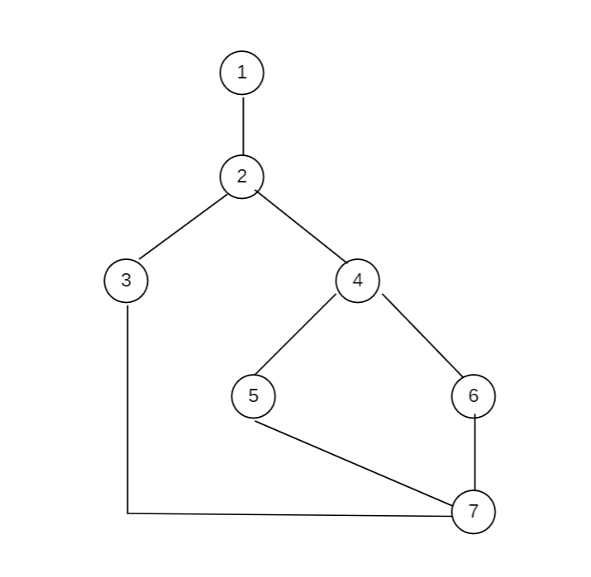

- Cyclomatic Complexity:
Method-1: Total number of inner regions + Outer region = 3
Method-2: Using Edges and Nodes; V(G) = E – N + 2
Here N=7, E=8
V(G) = 8 – 7 + 2 = 3
Method-3: Using Decision (Predicate) Nodes; V(G) = P + 1
V(G) = 2+1 = 3

- Independent Paths:
- Path1 (Invalid Input): 1,2,3,7
- Path2 (Login Successful): 1,2,4,5,7
- Path3 (Login Failed): 1,2,4,6,7

- Test Cases:
Path No. | Independent Path (Node Sequence) | Test Input | Expected Output
P1 | 1,2,3,7 | (“”,”1234”) | Invalid Input
P2 | 1,2,4,5,7 | (“farmer”,”1234”) | Login Successful
P3 | 1,2,4,6,7 | (“farmer”,”0000”) | Login Failed

- Execution:
def login_authentication(username, password):
if username == "" or password == "":
return "Invalid Input"
if username == "farmer" and password == "1234":
return "Login Successful"
else:
return "Login Failed"

import unittest
class TestLoginAuthentication(unittest.TestCase):
def test_invalid_input(self):
self.assertEqual(login_authentication("", "1234"), "Invalid Input")
def test_login_successful(self):
self.assertEqual(login_authentication("farmer", "1234"), "Login Successful")
def test_login_failed(self):
self.assertEqual(login_authentication("farmer", "0000"), "Login Failed")
if __name__ == "__main__":
unittest.main()

Output:
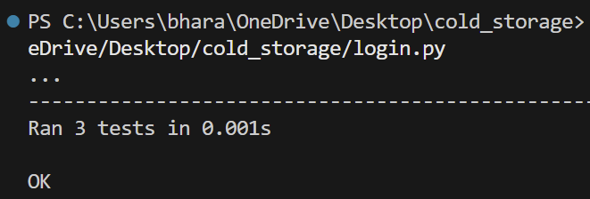

- Black-Box Testing:
- Equivalence Partitioning:

Username/Password:
Class | Input | Type
EC1 | Correct username and password | Valid
EC2 | Empty username or password | Invalid
EC3 | Incorrect username or password | Invalid

- Boundary Value Analysis:
Test | Input | Expected Output
B1 | username=”” | Invalid Input
B2 | username=”farmer”  password=”1234” | Login Successful
B3 | username=”farmer”  password=”9999” | Login Failed

  - Code Snippet-2:
def validate_storage(quantity, available_capacity):
if quantity <= 0:
return "Invalid Quantity"
if quantity > available_capacity:
return "Storage Not Available"
return "Booking Confirmed"

- White-Box Testing:
- Control Flow Graph:


- Cyclomatic Complexity:
Method-1: Total number of inner regions + Outer region = 3
Method-2: Using Edges and Nodes; V(G) = E – N + 2
Here N=7, E=8
V(G) = 8 – 7 + 2 = 3
Method-3: Using Decision (Predicate) Nodes; V(G) = P + 1
V(G) = 2+1 = 3

- Independent Paths:
- Path1 (Invalid Quantity): 1,2,3,7
- Path2 (Storage Not Available): 1,2,4,5,7
- Path3 (Booking Confirmed): 1,2,4,6,7

- Test Cases:
Path No. | Independent Path (Node Sequence) | Test Input | Expected Output
P1 | 1,2,3,7 | (0,100) | Invalid Quantity
P2 | 1,2,4,5,7 | (150,100) | Storage Not Available
P3 | 1,2,4,6,7 | (50,100) | Booking Confirmed

- Execution:

def validate_storage(quantity, available_capacity):
if quantity <= 0:
return "Invalid Quantity"
if quantity > available_capacity:
return "Storage Not Available"
return "Booking Confirmed"

import unittest
class TestValidateStorage(unittest.TestCase):
def test_invalid_quantity(self):
self.assertEqual(validate_storage(0,100),"Invalid Quantity")
def test_storage_not_available(self):
self.assertEqual(validate_storage(150,100),"Storage Not Available")
def test_booking_confirmed(self):
self.assertEqual(validate_storage(50,100),"Booking Confirmed")
if __name__ == "__main__":
unittest.main()
Output:
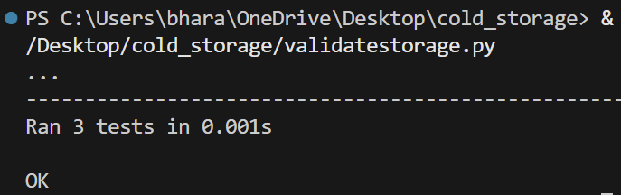

- Black-Box Testing:
- Equivalence Partitioning:

Quantity:
Class | Input Range | Type
EC1 | quantity<=0 | Invalid
EC2 | 1<=quantity<=capacity | Valid
EC3 | quantity>capacity | Invalid

- Boundary Value Analysis:
Test | Input | Expected Output
B1 | quantity=0 | Invalid Quantity
B2 | quantity=capacity | Booking Confirmed
B3 | quantity=capacity+1 | Storage Not Available

- CONCLUSION:
This Software Requirements Specification (SRS) describes the overall design and requirements of the Cold Storage Management System. The document explains how the proposed system is intended to simplify the process of managing and using cold storage facilities. Through this system, farmers can easily find nearby cold storages, check the availability of space, and request storage based on the type of crop, quantity, and required storage duration. At the same time, cold storage owners are able to manage their storage capacity, update availability, and monitor booking requests in a more organized way.
The SRS also presents the functional and non-functional requirements that guide how the system should operate. Important aspects such as the user interface, hardware and software interactions, communication methods, and performance expectations have been clearly described. Various UML diagrams, including use case diagrams, class diagrams, sequence diagrams, activity diagrams, state charts, component diagrams, and deployment diagrams, were used to illustrate the system structure and interactions between different modules. These diagrams help provide a clear understanding of how the system components work together.
Overall, this specification serves as a foundation for developing the Cold Storage Management System. By clearly defining system requirements and architecture, it supports the development of a practical solution that can help farmers access storage facilities more easily while allowing storage owners to manage their resources efficiently.

- REFERENCES:
- Edition, Pearson Education, 2016.
This book helped in understanding the fundamentals of software development processes, system requirements, and design approaches.
- Roger S. Pressman and Bruce R. Maxim, Software Engineering: A Practitioner’s Approach, 8th Edition, McGraw-Hill Education, 2015.
It was useful for learning about software project development, requirement specification, and system design techniques.
- IEEE Software Requirements Specification Standard (IEEE 830).
This standard was used as a reference for organizing and structuring the SRS document properly.
- Object Management Group (OMG), Unified Modelling Language (UML) Documentation.
This resource helped in understanding how to create UML diagrams such as use case diagrams, class diagrams, sequence diagrams, component diagrams, and deployment diagrams.
- In addition, various online learning materials and documentation related to StarUML and software engineering concepts were also consulted to better understand diagram modelling and system design.

- ACKNOWLEDGEMENTS:
We would like to express our sincere gratitude to everyone who supported us during the development of this project and the preparation of this Software Requirements Specification (SRS).

First, we would like to thank our faculty member for providing us with the guidance, suggestions, and valuable feedback throughout the different stages of this work. Their encouragement and direction helped us understand the concepts involved in system analysis and design more clearly.

We also extend our appreciation to our institution for providing the necessary resources and a supportive learning environment that made this work possible. The knowledge gained through our coursework and practical sessions played an important role in completing this project successfully.

DESIGN ARCHITECTURE

- COMPONENT DIAGRAM:
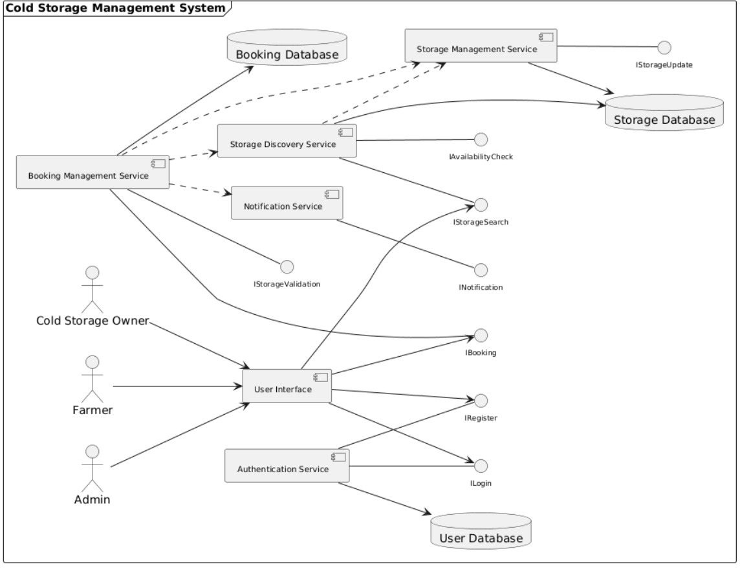
- DEPLOYMENT DIAGRAM:
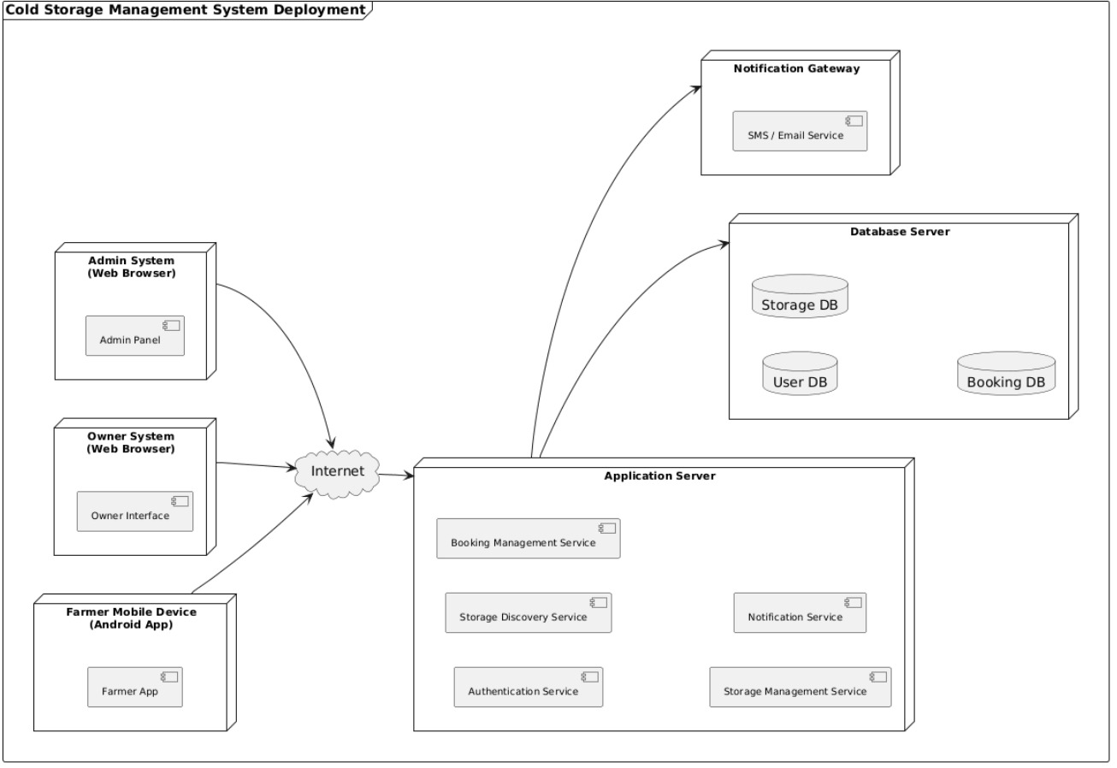

PRODUCT METRICS FOR ANALYSIS MODEL

FUNCTIONAL POINT ANALYSIS OF COLD STORAGE MANAGEMENT SYSTEM
- Calculation of Function Point:
- Calculation of UFP (Unadjusted Functional Point):
Information Domain Value | Count | Weightage Factor |  |  | Individual Sum | Sum
 |  | Simple | Average | Complex
External Inputs (EIs) | 5 | 3 | 4 | 6 | 2x3+2x4+1x6 | 20
External Outputs (EOs) | 4 | 4 | 5 | 7 | 1x4+2x5+1x7 | 21
External Inquiries (EQs) | 3 | 3 | 4 | 6 | 1x3+1x4+1x6 | 13
Internal Logical Files (ILFs) | 3 | 7 | 10 | 15 | 1x7+1x10+1x15 | 32
External Interface Files (EIFs) | 2 | 5 | 7 | 10 | 1x5+1x7 | 12
Total Sum |  |  |  |  |  | 98
Unadjusted Functional Point value = 98

- Calculation of CAF (Complexity Adjustment Factor):
S.No. | Questions | Rating
1. | Does the system require a reliable backup and recovery? | 3
2. | Are specialized data communications required to transfer information to or from the application? | 4
3. | Are there distributed processing functions? | 3
4. | Is performance critical? | 4
5. | Will the system run in an existing, heavily utilized operational environment? | 3
6. | Does the system require online data entry? | 5
7. | Does the online data entry require the input transaction to be built over multiple screens or operations? | 4
8. | Are the ILFs updated online? | 5
9. | Are the inputs, outputs, files, or inquiries complex? | 4
10. | Is the internal processing complex? | 3
11. | Is the code designed to be reusable? | 3
12. | Are conversion and installation included in the design? | 2
13. | Is the system designed for multiple installations in different organizations? | 3
14. | Is the application designed or facilitate change and ease of use by the user? | 4
CAF: [0.65 + 0.01 x (Sum of Ratings)] = 0.65 + 0.01 x 50 = 0.65 + 0.5 = 1.15
- Calculation of FP (Function Point):
FP = UFP x CAF = 98 x 1.15 = 112.7

- What 112.7 Function Point means?
- It indicates the functional size of the software system after adjusting for system complexity.
- Historically, 1 FP ≈ 10 hours of development, then the total estimated time required to complete the project is 112.7 x 10 =1127 hours.
- If a developer works for 8 hours a day, total number of days required is 1127/8 = 141.875, which is approximately equal to 142 days.
- If the project needs to be completed in 2 months, the size of the team required is 142/60 = 2.367, which is approximately 3 developers.
- If Developer cost = ₹1000 per hour, estimated project cost = 1127 x 1000 = ₹11,27,000.

EMPERICAL ESTIMATION MODELS:
COCOMO MODEL

- Basic COCOMO Model:
Cold Storage Management System comes under the ORGANIC category with 5 KLOC.
The basic COCOMO is used for quick and slightly rough calculations of software costs. The constant values A, B, C and D for the Basic Model for different categories of software model.
Software Project | A | B | C | D
Organic | 2.4 | 1.05 | 2.5 | 0.38
Semi Detached | 3.0 | 1.12 | 2.5 | 0.35
Embedded | 3.6 | 1.20 | 2.5 | 0.32
Calculation of Effort:
Effort (E) = A*(KLOC)^{B} = 2.4*(5)^{1.05} =2.4 * 5.42 = 13 Person – Months.
Calculation of Time:
Time (T) = C*(Effort)^{D} = 2.5*(13)^{0.38} = 2.5 * 2.65 = 6.62 Months.
Calculation of Persons Required:
Persons required = Effort/Time = 13/6.62 = 1.96 = 2 Developers.

- Intermediate COCOMO Model:
In the intermediate COCOMO model, various other factors such as reliability, experience, and capability are considered along with LOC to estimate effort and time schedule.
These factors are known as Cost Drivers and this model utilizes 15 such drivers for cost estimation. They are:
- Required software reliability extent
- Size of application database
- The complexity of the product
- Run-time performance constraints
- Memory constraints
- The volatility of the virtual machine environment
- Required turnabout time
- Analyst capability
- Software Engineering capability
- Applications Experience
- Virtual Machine Experience
- Programming language Experience
- Use of software tools
- Application of software Engineering methods
- Required development schedule
Cost drivers Number | Ratings
 | Very Low | Low | Nominal | High | Very High | Extra High
1 | 0.75 | 0.88 | 1.00 | 1.15 | 1.40 | -
2 | - | 0.94 | 1.00 | 1.08 | 1.16 | -
3 | 0.70 | 0.85 | 1.00 | 1.15 | 1.30 | 1.65
4 | - | - | 1.00 | 1.11 | 1.30 | 1.66
5 | - | - | 1.00 | 1.06 | 1.21 | 1.56
6 | - | 0.87 | 1.00 | 1.15 | 1.30 | -
7 | - | 0.87 | 1.00 | 1.07 | 1.15 | -
8 | 1.46 | 1.19 | 1.00 | 0.86 | 0.71 | -
9 | 1.29 | 1.13 | 1.00 | 0.91 | 0.82 | -
10 | 1.42 | 1.17 | 1.00 | 0.86 | 0.70 | -
11 | 1.21 | 1.10 | 1.00 | 0.90 | - | -
12 | 1.14 | 1.07 | 1.00 | 0.95 | - | -
13 | 1.24 | 1.10 | 1.00 | 0.91 | 0.82 | -
14 | 1.24 | 1.10 | 1.00 | 0.91 | 0.83 | -
15 | 1.23 | 1.08 | 1.00 | 1.04 | 1.10 | -
Calculation of EAF:
EAF: Product of cost drivers
EAF = 1.00*0.94*1.00*1.00*1.00*0.87*1.00*0.86*1.00*1.00*1.00*1.00*0.91*1.00*1.00 = 0.64
Calculation of Effort:
Effort (E) = (A*(KLOC)^{B}) * EAF = (2.4*(5)^{1.05}) * 0.64 = 13 * 0.64 = 8.32 Person – Months.
Calculation of Time:
Time (T) = C*(Effort)^{D} = 2.5 * (8.32)^{0.38}= 2.5 * 2.24 = 5.6 Months.
Calculation of Persons Required:
Persons Required = Effort/Time = 8.32/5.6 = 1.5 = 2 Developers.

